**Software Engineering and Data Science, SEIS 763: Machine Learning**

**Assignment #8 (100 points)**

**Due Date: November 15th**

**PRAGYA VERMA (101276204)**

1. Experiment your SVM RBF model with different “***box constraints***” and “***kernel***

***scales / gamma***”.

**Ans:**

%% loading CellDNA data

CellDNA = readtable("ML_HW_Data_CellDNA.csv");

CellDNA = table2array(CellDNA);

%% Converting target dependent variable (last column) to binary values of either 0sor 1s for your two-class classification

Y = CellDNA(:,14);

Y(Y>0) = 1;

%% Assigning X variables and performing standardization

X = zscore(CellDNA(:,1:13));

%% SVM RBF Model with Box Constraints

F_score = []; Accuracy = []; Recall = []; Precision = [];

BC = [0.1, 0.5, 1, 1.5, 2, 2.5, 3];

for i = BC

disp(['For Box Constraint = ' num2str(i)])

SVM = fitcsvm(X,Y, 'KernelFunction', 'rbf', 'KernelScale', 1, 'BoxConstraint',i);

[labels, scores] = predict(SVM, X);

[ClassPerformance, OverallAccuracy] = CFM_Stats(Y, labels)

F_score = [F_score, ClassPerformance.Fscore];

Accuracy = [Accuracy, OverallAccuracy];

Recall = [Recall, ClassPerformance.Fscore];

Precision = [Precision, ClassPerformance.Fscore];

end

figure,

subplot(2,2,1), plot(BC, F_score(1, :), 'r', BC, F_score(2, :), 'b'),

title('F score'), grid on, ylim([0.3, 1.05]), legend({ 'class0', 'class1'}), xlabel('BoxC')

subplot(2,2,2), plot(BC, Accuracy(1, :), 'r'),

title('Overall Acc'), grid on, ylim([0.3, 1.05]), legend({ 'overall'}), xlabel('BoxC')

subplot(2,2,3), plot(BC, Recall(1, :), 'r', BC, Recall(2, :), 'b'),

title('Recall'), grid on, ylim([0.3, 1.05]), legend({ 'class0', 'class1'}), xlabel('BoxC')

subplot(2,2,4), plot(BC, Precision(1, :), 'r', BC, Precision(2, :), 'b'),

title('Precision'), grid on, ylim([0.3, 1.05]), legend({ 'class0', 'class1'}), xlabel('BoxC')

%% SVM RBF Model with Kernel Scales

F_score = []; Accuracy = []; Recall = []; Precision = [];

KS = [0.1, 0.5, 1, 1.5, 2, 2.5, 3];

for i = KS

disp(['For Kernel Scale = ' num2str(i)])

SVM = fitcsvm(X,Y, 'KernelFunction', 'rbf', 'KernelScale', i, 'BoxConstraint',1);

[labels, scores] = predict(SVM, X);

[ClassPerformance, OverallAccuracy] = CFM_Stats(Y, labels)

F_score = [F_score, ClassPerformance.Fscore];

Accuracy = [Accuracy, OverallAccuracy];

Recall = [Recall, ClassPerformance.Fscore];

Precision = [Precision, ClassPerformance.Fscore];

end

figure,

subplot(2,2,1), plot(KS, F_score(1, :), 'r', KS, F_score(2, :), 'b'),

title('F score'), grid on, ylim([0.6, 1.05]), legend({ 'class0', 'class1'}), xlabel('KS')

subplot(2,2,2), plot(KS, Accuracy(1, :), 'r'),

title('Overall Acc'), grid on, ylim([0.6, 1.05]), legend({ 'overall'}), xlabel('KS')

subplot(2,2,3), plot(KS, Recall(1, :), 'r', KS, Recall(2, :), 'b'),

title('Recall'), grid on, ylim([0.6, 1.05]), legend({ 'class0', 'class1'}), xlabel('KS')

subplot(2,2,4), plot(KS, Precision(1, :), 'r', KS, Precision(2, :), 'b'),

title('Precision'), grid on, ylim([0.6, 1.05]), legend({ 'class0', 'class1'}), xlabel('KS')

%% ROC curve plot for class 0 by SVM RBF Kernel Scales experiment

[xpos,ypos,T,AUC0] = perfcurve(Y,scores(:,1),0);

figure, plot(xpos,ypos)

xlim([-0.05 1.05]), ylim([-0.05,1.05])

xlabel('\bf FP rate'), ylabel('\bf TP rate')

title(['\bf ROC for class 0 by SVM, AUC0 = ' num2str(AUC0)])

%% ROC curve plot for class 1 by SVM RBF Kernel Scales experiment

[xpos,ypos,T,AUC1]=perfcurve(Y,scores(:,2),1);

figure, plot(xpos,ypos)

xlim([-0.05 1.05]), ylim([-0.05,1.05])

xlabel('\bf FP rate'), ylabel('\bf TP rate')

title(['\bf ROC for class 1 by SVM, AUC1 = ' num2str(AUC1)])

2. What is the accuracy, Precision, Recall, and F-score for each class prediction

under each of your above experiments?

**Box Constraint = 3 Kernel Scale = 3**

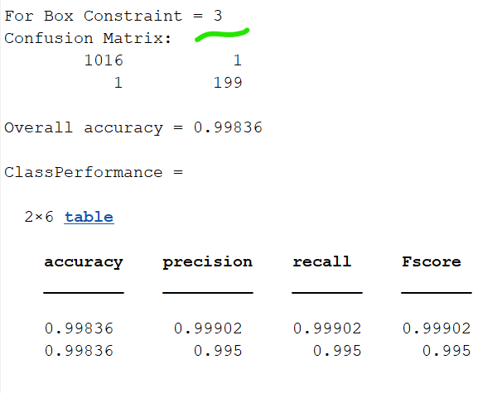 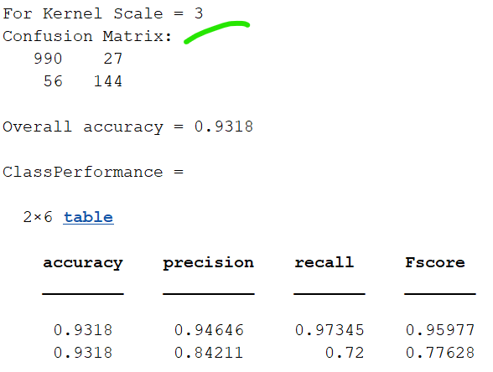

3. Is there any trend that you observed in your experiments?

**SVM RBF Model Box constraint:**

Box Constraint value increases, Overall accuracy increases

False Negative and False Positive decreases

**SVM RBF Model Kernel scales**

Kernel Value increases, overall accuracy decreases

False Negative and False Positive increases

4. **Optional**: plotting a graph with clear legends and tick labels to illustrate the trend

will be very helpful.

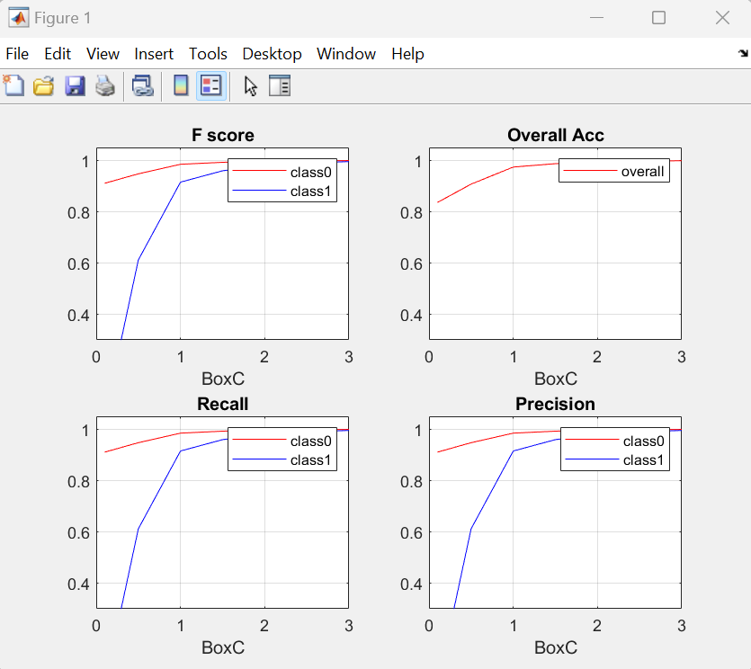

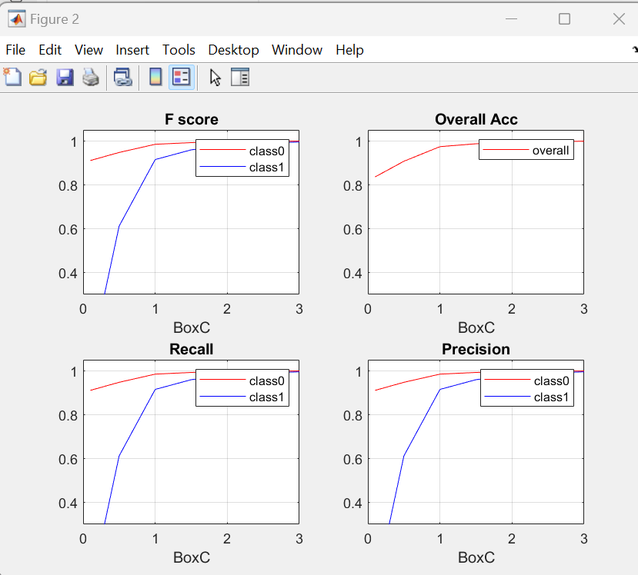

5. Create an ROC

Ans:

